Task1
Problem: A scientist recorded temperature readings (positive and negative). Determine the average of positive temperatures.
Pattern: Counting, Summation
Specification: (link)

In: size∈N, arr∈Z[1..size]
Out: avg∈R
Pre: size > 0 and COUNT(i=1..size, arr[i] > 0) > 0
Post: avg = (SUM(i=1..size, arr[i], arr[i] > 0)) / COUNT(i=1..size, arr[i] > 0)
Algorithm: (link)
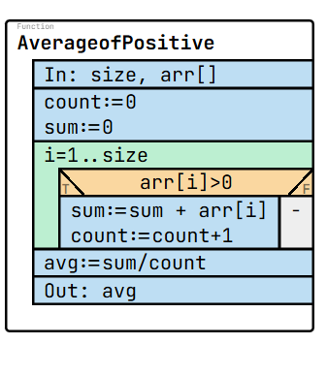
Test cases:
size: 3  arr: [3, -2, -1]  avg: 3.0 | arr: [1, -2, 3, -4, 5]  size: 5  avg: 3.0 | arr: [0, 2, 4]  size: 3  avg: 3.0 | arr: [10, 20, 30]  size: 3  avg: 20.0 | arr: [-3, 3, -2, 6]  size: 4  avg: 4.5

Code:
1  2  3  4  5  6  7  8  9  10  11  12  13  14  15  16  17  18  19  20  21  22  23  24  25  26  27  28  29  30  31  32  33  34  35  36  37  38  39  40 | namespace Task6  {  internal class Program  {  static void Main(string[] args)  {  Console.Write("Enter the size of the array: ");  int size = int.Parse(Console.ReadLine());  int[] arr = new int[size];  Console.WriteLine("Enter the elements:");  for (int i = 0; i < size; i++)  {  arr[i] = int.Parse(Console.ReadLine());  }  int sum = 0;  int count = 0;  for (int i = 0; i < size; i++)  {  if (arr[i] > 0)  {  sum += arr[i];  count++;  }  }  if (count > 0)  {  double avg = (double)sum / count;  Console.WriteLine("Average of positive numbers: " + avg);  }  else  {  Console.WriteLine("No positive numbers in the array.");  }  }  }  }

Questions:
1) Which patterns are applied in this task?
Answer: Counting and Summation
2) What are missing in the following specification? (What would you write instead of <q1> and <q2>)
In: size∈N, arr∈Z[1..size]
Out: avg∈R
Pre: size > 0 and COUNT(i=1..size, arr[i] > 0) > 0
Post: avg = <q1>(=1..size, arr[i], arr[i] > 0)) / <q2>(i=1..size, arr[i] > 0)
Answer: <q1> = SUM, <q2> = COUNT
3) What is missing in the following algorithm? (What would you write instead of <?>)
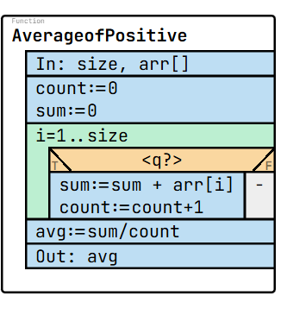
Answer: arr[i]>0
4) What will be result if input is this:
arr: [1, -2, 3, -4, 5]
size: 5
Answer: avg: 3.0

5) Analyze the following code that intends to calculate the sum of all elements in an array . The code compiles and runs without errors, but produces incorrect output. Identify the error and explain why it gives wrong results and on which line. (Hint: error is in lines between 7-37)
1  2  3  4  5  6  7  8  9  10  11  12  13  14  15  16  17  18  19  20  21  22  23  24  25  26  27  28  29  30  31  32  33  34  35  36  37  38  39  40 | namespace Task6  {  internal class Program  {  static void Main(string[] args)  {  Console.Write("Enter the size of the array: ");  int size = int.Parse(Console.ReadLine());  int[] arr = new int[size];  Console.WriteLine("Enter the elements:");  for (int i = 0; i < size; i++)  {  arr[i] = int.Parse(Console.ReadLine());  }  int sum = 0;  int count = 0;  for (int i = 0; i < size; i++)  {  if (arr[i] < 0)  {  sum += arr[i];  count++;  }  }  if (count > 0)  {  double avg = (double)sum / count;  Console.WriteLine("Average of positive numbers: " + avg);  }  else  {  Console.WriteLine("No positive numbers in the array.");  }  }  }  }
Answer: Line 22 (arr[i] < 0 is written instead of arr[i] > 0)

Task2
Problem: Given two arrays of integers, list all elements that appear in both arrays.
Patterns: Multiple item selection, Decision
Specification: (link)
In: size1∈N, size2∈N, arr1∈Z[1..size1], arr2∈Z[1..size2]
Out: count∈N, result∈Z[1..count]
Pre: size1 ≥ 0 and size2 ≥ 0
Post: (count, result) = MIS(i=1..size1, ∃j∈[1..size2]: (arr1[i] = arr2[j]), arr1[i])

Algortihm: (link)
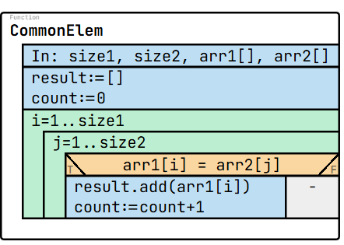
Test cases:
size1: 5  size2: 4  arr1: [-3, 12, 4, 1, 0]  arr2: [4, 3, 5, 12]  count: 2  result: [12, 4] | size1: 4  size2: 5  arr1: [4, 3, 5, 12]  arr2: [-3, 11, 14, 1, 0]  count: 0  result: [] | size1: 3  size2: 3  arr1: [1, 2, 3]  arr2: [3, 4, 5]  count: 1  result: [3] | size1: 3  size2: 2  arr1: [5, 10, 15]  arr2: [5, 15]  count: 2  result: [5, 15] | size1: 3  size2: 2  arr1: [2, 2, 3]  arr2: [2, 3]  count: 3  result: [2,2,3]

Code:
1  2  3  4  5  6  7  8  9  10  11  12  13  14  15  16  17  18  19  20  21  22  23  24  25  26  27  28  29  30  31  32  33  34  35  36  37  38  39  40  41  42  43  44 | namespace Task7  {  internal class Program  {  static void Main(string[] args)  {  Console.Write("Enter the size of first array: ");  int size1 = int.Parse(Console.ReadLine());  Console.Write("Enter the size of second array: ");  int size2 = int.Parse(Console.ReadLine());  int[] arr1 = new int[size1];  int[] arr2 = new int[size2];  Console.WriteLine("Enter elements of first array:");  for (int i = 0; i < size1; i++)  arr1[i] = int.Parse(Console.ReadLine());  Console.WriteLine("Enter elements of second array:");  for (int j = 0; j < size2; j++)  arr2[j] = int.Parse(Console.ReadLine());  int[] result = new int[Math.Min(size1, size2)];  int count = 0;  for (int i = 0; i < size1; i++)  {  for (int j = 0; j < size2; j++)  {  if (arr1[i] == arr2[j])  {  result[count] = arr1[i];  count++;  break;  }  }  }  Console.WriteLine("Common elements: ");  for (int i = 0; i < count; i++)  Console.Write(result[i] + " ");  }  }  }

Questions:
1) Which patterns are applied in this task?
Answer: Multiple item selection, Decision
2) What is missing in the following specification? (What would you write instead of <q1>)
In: size1∈N, size2∈N, arr1∈Z[1..size1], arr2∈Z[1..size2]
Out: count∈N, result∈Z[1..count]
Pre: size1 ≥ 0 and size2 ≥ 0
Post: (count, result) = <q1> (i=1..size1, ∃j∈[1..size2]: (arr1[i] = arr2[j]), arr1[i])
Answer: <q1> = MIS
3) What is missing in the following algorithm? (What would you write instead of <?>)
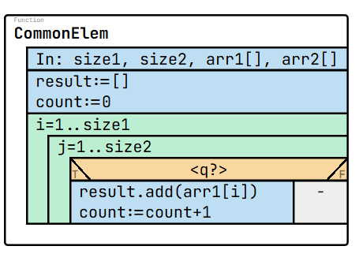
Answer: arr1[i] = arr2[j]
4) What will be result if input is this:
size1: 4
size2: 5
arr1: [4, 3, 5, 12]
arr2: [-3, 11, 14, 1, 0]
Answer: count: 0,result: []
5) Analyze the following code that intends to calculate the sum of all elements in an array . The code compiles and runs without errors, but produces incorrect output. Identify the error and explain why it gives wrong results and on which line. (Hint: error is in lines between 7-41)
1  2  3  4  5  6  7  8  9  10  11  12  13  14  15  16  17  18  19  20  21  22  23  24  25  26  27  28  29  30  31  32  33  34  35  36  37  38  39  40  41  42  43  44 | namespace Task7  {  internal class Program  {  static void Main(string[] args)  {  Console.Write("Enter the size of first array: ");  int size1 = int.Parse(Console.ReadLine());  Console.Write("Enter the size of second array: ");  int size2 = int.Parse(Console.ReadLine());  int[] arr1 = new int[size1];  int[] arr2 = new int[size2];  Console.WriteLine("Enter elements of first array:");  for (int i = 0; i < size1; i++)  arr1[i] = int.Parse(Console.ReadLine());  Console.WriteLine("Enter elements of second array:");  for (int j = 0; j < size2; j++)  arr2[j] = int.Parse(Console.ReadLine());  int[] result = new int[Math.Min(size1, size2)];  int count = 0;  for (int i = 0; i < size1; i++)  {  for (int j = 0; j < size2; j++)  {  if (arr1[i] != arr2[j])  {  result[count] = arr1[i];  count++;  break;  }  }  }  Console.WriteLine("Common elements: ");  for (int i = 0; i < count; i++)  Console.Write(result[i] + " ");  }  }  }
Answer: Line 30, is written arr1[i] != arr2[j]) instead of arr1[i] == arr2[j])
Task3
Problem: A company stores monthly sales in a matrix (rows = months, columns = days). Find the highest sale per month and list them in a new array.
Patterns: Maximum selection
Specification: (link)
In: rows∈N, cols∈N, matrix∈Z[1..rows, 1..cols]
Out: maxRow∈Z[1..rows]
Pre: rows > 0 and cols > 0
Post: ∀i ∈ [1..rows]: ((,maxRow[i]) = MAX(j=1..cols, matrix[i,j]))
Algorithm: (link)
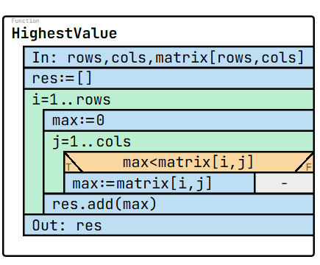
Test cases:
rows: 3  cols: 3  matrix: [[3,5,2],[7,1,4],[0,9,8]]  maxRow: [5,7,9] | rows: 2  cols: 2  matrix: [[1,1],[1,1]]  maxRow: [1,1] | rows: 1  cols: 3  matrix: [[10,2,3]]  maxRow: [10] | rows: 2  cols: 3  matrix: [[5,8,12],[4,6,7]]  maxRow: [12,7] | rows: 2  cols: 2  matrix: [[0,0],[0,0]]  maxRow: [0,0]

Code:
1  2  3  4  5  6  7  8  9  10  11  12  13  14  15  16  17  18  19  20  21  22  23  24  25  26  27  28  29  30  31  32  33  34  35  36  37  38  39  40  41  42  43  44 | namespace Task8  {  internal class Program  {  static void Main(string[] args)  {  Console.Write("Enter number of rows: ");  int rows = int.Parse(Console.ReadLine());  Console.Write("Enter number of columns: ");  int cols = int.Parse(Console.ReadLine());  int[,] matrix = new int[rows, cols];  int[] maxRow = new int[rows];  Console.WriteLine("Enter matrix elements:");  for (int i = 0; i < rows; i++)  {  for (int j = 0; j < cols; j++)  {  matrix[i, j] = int.Parse(Console.ReadLine());  }  }  for (int i = 0; i < rows; i++)  {  int max = matrix[i, 0];  for (int j = 1; j < cols; j++)  {  if (matrix[i, j] > max)  {  max = matrix[i, j];  }  }  maxRow[i] = max;  }  Console.WriteLine("Highest values in each row:");  for (int i = 0; i < rows; i++)  {  Console.Write(maxRow[i] + " ");  }  }  }  }

Questions:
1) Which pattern is applied in this task?
Answer: Maximum selection
2) What is the output if this:
rows: 3
cols: 3
matrix: [[3,5,2],[7,1,4],[0,9,8]]
maxRow: ?
Answer: [5,7,9]
3) What is missing in the following specification? (What would you write instead of <q1>)
In: rows∈N, cols∈N, matrix∈Z[1..rows, 1..cols]
Out: maxRow∈Z[1..rows]
Pre: rows > 0 and cols > 0
Post: ∀i ∈ [1..rows]: ((,maxRow[i]) = <q?>(j=1..cols, matrix[i,j]))
Answer: MAX
4) What is missing in the following algorithm? (What would you write instead of <?>)
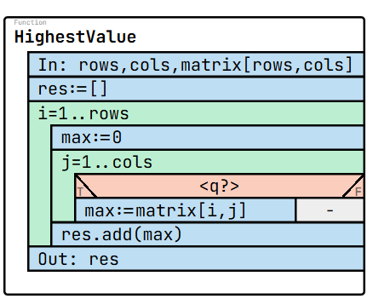
Answer: max<matrix[i,j]
5) Analyze the following code that intends to calculate the sum of all elements in an array . The code compiles and runs without errors, but produces incorrect output. Identify the error and explain why it gives wrong results and on which line. (Hint: error is in lines between 7-43)
1  2  3  4  5  6  7  8  9  10  11  12  13  14  15  16  17  18  19  20  21  22  23  24  25  26  27  28  29  30  31  32  33  34  35  36  37  38  39  40  41  42  43  44 | namespace Task8  {  internal class Program  {  static void Main(string[] args)  {  Console.Write("Enter number of rows: ");  int rows = int.Parse(Console.ReadLine());  Console.Write("Enter number of columns: ");  int cols = int.Parse(Console.ReadLine());  int[,] matrix = new int[rows, cols];  int[] maxRow = new int[rows];  Console.WriteLine("Enter matrix elements:");  for (int i = 0; i < rows; i++)  {  for (int j = 0; j < cols; j++)  {  matrix[i, j] = int.Parse(Console.ReadLine());  }  }  for (int i = 0; i < rows; i++)  {  int max = matrix[i, 0];  for (int j = 1; j < cols; j++)  {  if (matrix[i, j] < max)  {  max = matrix[i, j];  }  }  maxRow[i] = max;  }  Console.WriteLine("Highest values in each row:");  for (int i = 0; i < rows; i++)  {  Console.Write(maxRow[i] + " ");  }  }  }  }

Answer: Line 29, “<” is written instead of “>”

Task 4
Problem: Given an array of integers, find the smallest value and how many times it appears.
Patterns: Minimum selection, Counting
Specification (link)
In: size∈N, arr∈Z[1..size]
Out: min∈Z, count∈N
Pre: size > 0
Post: (,min) = MIN(i=1..size, arr[i]) and
count = COUNT(i=1..size, arr[i] = min)
Algorithm (link)
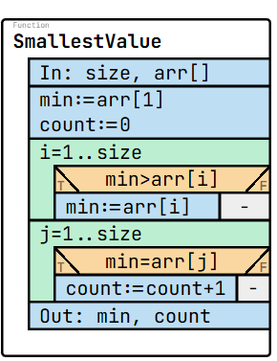
Test cases:
size: 5  arr: [1,2,3,1,1]  min: 1  count: 3 | size: 5  arr: [5,4,3,1,1]  min: 1  count: 2 | size: 3  arr: [-2,-2,-1]  min: -2  count: 2 | size: 3  arr: [0,0,0]  min: 0  count: 3 | size: 1  arr: [10]  min: 10  count: 1

Code:
1  2  3  4  5  6  7  8  9  10  11  12  13  14  15  16  17  18  19  20  21  22  23  24  25  26  27  28  29  30  31  32  33  34  35  36  37  38  39 | namespace Task9  {  internal class Program  {  static void Main(string[] args)  {  Console.Write("Enter the size of the array: ");  int size = int.Parse(Console.ReadLine());  int[] arr = new int[size];  Console.WriteLine("Enter the elements:");  for (int i = 0; i < size; i++)  {  arr[i] = int.Parse(Console.ReadLine());  }  int min = arr[0];  for (int i = 1; i < size; i++)  {  if (arr[i] < min)  {  min = arr[i];  }  }  int count = 0;  for (int i = 0; i < size; i++)  {  if (arr[i] == min)  {  count++;  }  }  Console.WriteLine("Minimum value: " + min);  Console.WriteLine("Count: " + count);  }  }  }

Question:
1) Which patterns are applied in this task?
Answer: Minimum selection and Counting
2) If size: 3, arr: [0,0,0] what is the minimum and count?
Answer: min = 0, count = 3
3) What are missing in the following specification? (What would you write instead of <q1> and <q2>)
In: size∈N, arr∈Z[1..size]
Out: min∈Z, count∈N
Pre: size > 0
Post: (,min) = <q1>(i=1..size, arr[i]) and
count = <q2>(i=1..size, arr[i] = min)
Answer: <q1> = MAX, <q2> = COUNT
4) What is missing in the following algorithm? (What would you write instead of <?>)
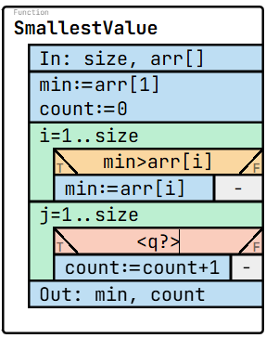
Answer: min=arr[j]

5) Analyze the following code that intends to calculate the sum of all elements in an array . The code compiles and runs without errors, but produces incorrect output. Identify the error and explain why it gives wrong results and on which line. (Hint: error is in lines between 7-43)
1  2  3  4  5  6  7  8  9  10  11  12  13  14  15  16  17  18  19  20  21  22  23  24  25  26  27  28  29  30  31  32  33  34  35  36  37  38  39 | namespace Task9  {  internal class Program  {  static void Main(string[] args)  {  Console.Write("Enter the size of the array: ");  int size = int.Parse(Console.ReadLine());  int[] arr = new int[size];  Console.WriteLine("Enter the elements:");  for (int i = 0; i < size; i++)  {  arr[i] = int.Parse(Console.ReadLine());  }  int min = arr[0];  for (int i = 1; i < size; i++)  {  if (arr[i] < min)  {  min = arr[i];  }  }  int count = 0;  for (int i = 0; i < size; i++)  {  if (arr[i] != min)  {  count++;  }  }  Console.WriteLine("Minimum value: " + min);  Console.WriteLine("Count: " + count);  }  }  }

Answer: Line 29, != is written instead of ==

Task5
Problem: A company stores employee records (name, ID, salary, yearsWorked). Determine how many employees are eligible for a bonus if they have (yearsWorked > 5) and (salary < 4000).
Patterns: Counting + Decision
Specification (link)
In: size∈N, emp∈Temployee[1..size],
Temployee = (name:S x id:N x salary:Z x yearsWorked:N)
Out: count∈N
Pre: size > 0
Post: count = COUNT(i=1..size, emp[i].yearsWorked > 5 and emp[i].salary < 4000)
Algorithm (link)
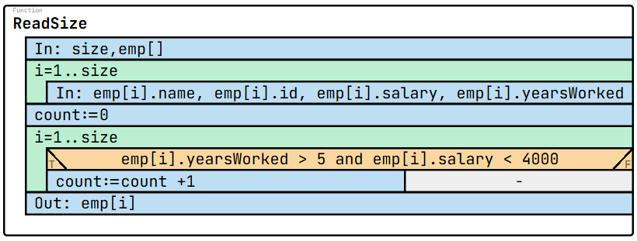
Test cases:
size: 3  emp: [  {name: "Ali", id: 1, salary: 3500, yearsWorked: 6},  {name: "Lia", id: 2, salary: 4000, yearsWorked: 4},  {name: "Ken", id: 3, salary: 3800, yearsWorked: 7}  ]  count: 2 | size: 3  emp: [  {name: "John", id: 1, salary: 2000, yearsWorked: 10},  {name: "Mary", id: 2, salary: 5000, yearsWorked: 8},  {name: "Tom", id: 3, salary: 3500, yearsWorked: 2}  ]  count: 1 | size: 3  emp: [  {name: "Eva", id: 1, salary: 4100, yearsWorked: 6},  {name: "Ben", id: 2, salary: 3900, yearsWorked: 3},  {name: "Kim", id: 3, salary: 3700, yearsWorked: 7}  ]  count: 1 | size: 2  emp: [  {name: "Sara", id: 1, salary: 4500, yearsWorked: 8},  {name: "Mia", id: 2, salary: 4700, yearsWorked: 9}  ]  count: 0 | size: 3  emp: [  {name: "Noah", id: 1, salary: 3900, yearsWorked: 6},  {name: "Adam", id: 2, salary: 3800, yearsWorked: 6},  {name: "Lily", id: 3, salary: 3200, yearsWorked: 4}  ]  count: 2

Code:
1  2  3  4  5  6  7  8  9  10  11  12  13  14  15  16  17  18  19  20  21  22  23  24  25  26  27  28  29  30  31  32  33  34  35  36  37  38  39  40  41  42  43  44  45 | namespace Task10  {  internal class Program  {  struct Employee  {  public string name;  public int id;  public int salary;  public int yearsWorked;  }  static void Main(string[] args)  {  Console.Write("Enter number of employees: ");  int size = int.Parse(Console.ReadLine());  Employee[] emp = new Employee[size];  for (int i = 0; i < size; i++)  {  Console.WriteLine($"Enter data for employee {i + 1}:");  Console.Write("Name: ");  emp[i].name = Console.ReadLine();  Console.Write("ID: ");  emp[i].id = int.Parse(Console.ReadLine());  Console.Write("Salary: ");  emp[i].salary = int.Parse(Console.ReadLine());  Console.Write("Years Worked: ");  emp[i].yearsWorked = int.Parse(Console.ReadLine());  }  int count = 0;  for (int i = 0; i < size; i++)  {  if (emp[i].yearsWorked > 5 && emp[i].salary < 4000)  {  count++;  }  }  Console.WriteLine("Number of employees eligible for bonus: " + count);  }  }  }

Questions:
1) Which patterns are applied in this task?
Answer: Counting and Decision
2) If there are 4 employees, how many times is the condition checked?
Answer: 4 times (once per employee).
3) What is missing in the following algorithm? (What would you write instead of <q1>)
In: size∈N, emp∈Temployee[1..size],
Temployee = (name:S x id:N x salary:Z x yearsWorked:N)
Out: count∈N
Pre: size > 0
Post: count = <q1>(i=1..size, emp[i].yearsWorked > 5 and emp[i].salary < 4000)
Answer: COUNT
4) What are missing in the following algorithm? (What would you write instead of <q1> and <q2> )
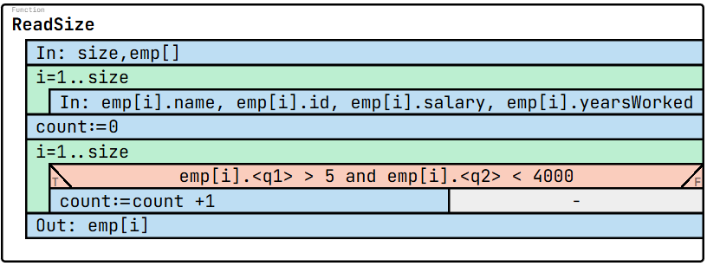
Answer: <q1> - yearsWorked, <q2> - salary
5) Analyze the following code that intends to calculate the sum of all elements in an array . The code compiles and runs without errors, but produces incorrect output. Identify the error and explain why it gives wrong results and on which line. (Hint: error is in lines between 7-43)
1  2  3  4  5  6  7  8  9  10  11  12  13  14  15  16  17  18  19  20  21  22  23  24  25  26  27  28  29  30  31  32  33  34  35  36  37  38  39  40  41  42  43  44  45 | namespace Task10  {  internal class Program  {  struct Employee  {  public string name;  public int id;  public int salary;  public int yearsWorked;  }  static void Main(string[] args)  {  Console.Write("Enter number of employees: ");  int size = int.Parse(Console.ReadLine());  Employee[] emp = new Employee[size];  for (int i = 0; i < size; i++)  {  Console.WriteLine($"Enter data for employee {i + 1}:");  Console.Write("Name: ");  emp[i].name = Console.ReadLine();  Console.Write("ID: ");  emp[i].id = int.Parse(Console.ReadLine());  Console.Write("Salary: ");  emp[i].salary = int.Parse(Console.ReadLine());  Console.Write("Years Worked: ");  emp[i].yearsWorked = int.Parse(Console.ReadLine());  }  int count = 0;  for (int i = 0; i < size; i++)  {  if (emp[i].yearsWorked > 5 || emp[i].salary < 4000)  {  count++;  }  }  Console.WriteLine("Number of employees eligible for bonus: " + count);  }  }  }

Answer: Line 36, && is written instead of &&

